**LAB 4**



**fall 2023**

**Signal Prossacing**

**Submitted by**: **Muhammad Ilyas**

**Registration No**. :21PWCSE2055

**Class Section**: **B**

Submitted to:

**Engr. Sir ABDULLAH HAMID**

**Department of Computer Systems Engineering**

**University of Engineering and Technology, Peshawar**

Task 1: Write a program that takes N UNIX commands as arguments, creates N child processes, each of them implementing their respective commands. Parent process shall wait for all the child processes and receive and print the exit status of the child processes.

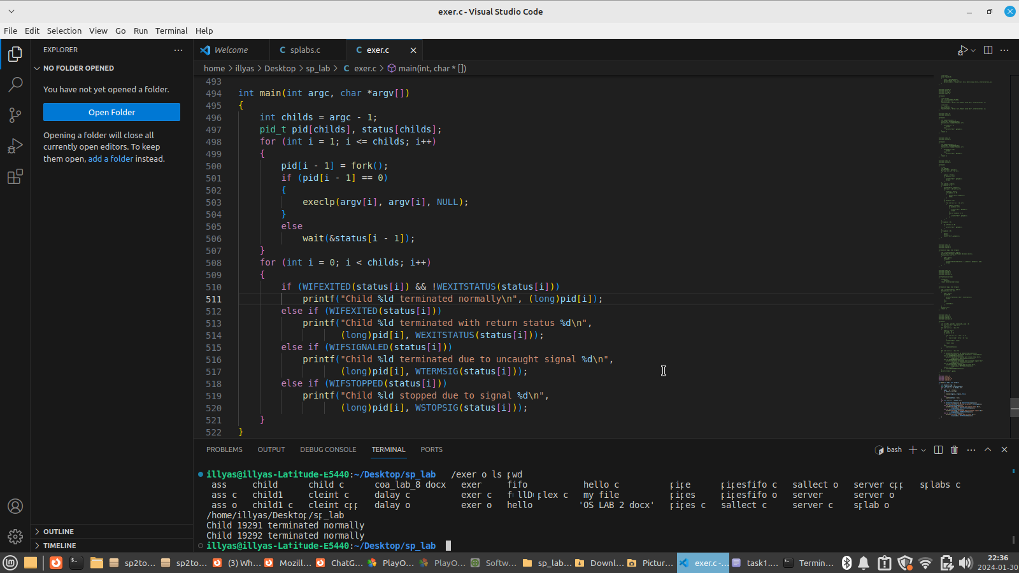



Task 2: a. Write a program that takes integers as arguments and adds them.

b. Write a program that takes integers as arguments and multiplies them.

c. Write a program that takes integers as arguments & adds & multiplies them using the above two programs.

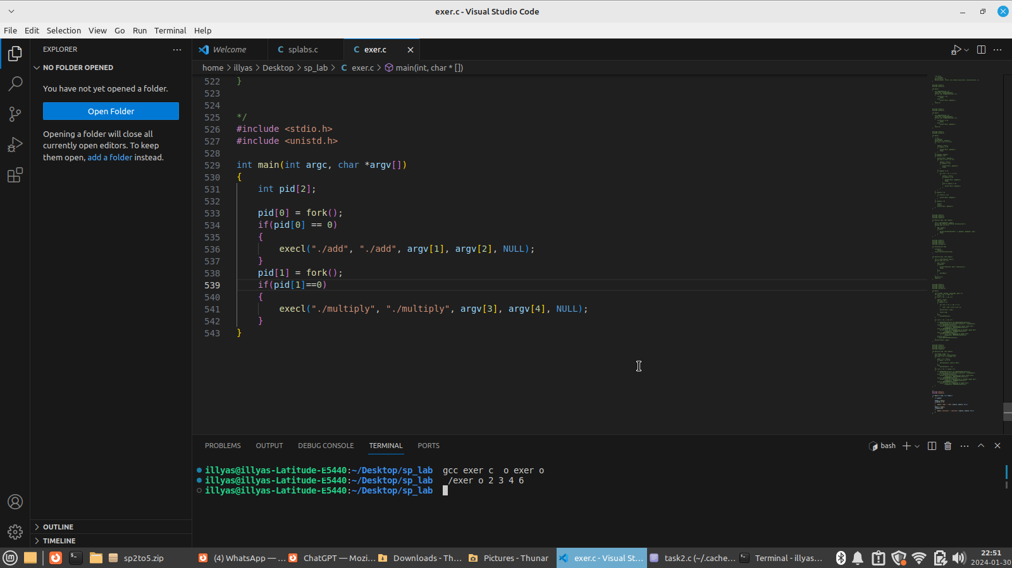



Task 3: Write a program “minmax.c” that takes an array as command line arguments. Program executes min.c and max.c programs in its two child processes. One child process calculates and returns the min value and other calculates and returns the max value in the array. The program “minmax.c” shall receive the values returned by the child processes and display these values.

